Spotify nots
<doctype html>:=
- Doctype html browser ko yeh bata ki yeh jo kam kr rhe hai vo kon se virson ka html hai

Used Tags:<head>
- <head> := head tag ek container hai metadata(data about data)ke liye jo html tag or body tag ke bich placed hota hai.
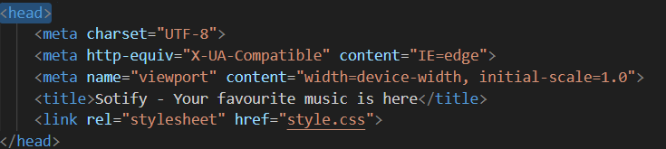
- <Meta charset =”UFT-8”> :=
- UTF stands for “Unicode Transfomation format-8bits” charset ye batata hai ki UTF-8 me kitne character honge.
- UTF-8 me sare character or symbol include hota hai.

3.<meta name=”viewport” contant=”width=device-width,initial-scale=1.0”> :=
- viewport web page me user ka visible area(Drishya skhetra) hota hai.
- Jaha user use kisi bhi screen me comfortably dekh skta hai.picture ko or contant ko bhi.
- Width ka mtlb device ke width ke equal krna or initial-scale ka mtlb use size ko zoom level krna .

4.<link ref=” stylesheet” href=” style.css”:=
- Bahri Stylesheet ka use html ke page ko link krne ke ya define krne ke liye kiya jata hai.

Used tags:<body>
1.<body> :-
- Jo bhi data hm web page me dekhte hai vo sb body tag ke ander likha hota hai.

Used tages:<nav>
2.<nav>:-
- Iska use hm navigasion banne ke liye krte hai.
- Hamare web site me jitne page hote hunke links ko rkhte hai.

3.<list>:-
- list tag define krta hai list item ko.
- list tag used in orderedlist <ol> or unorderlist<ul>
- an orderedlist can be numerical & alphabetical.
- an unorderlist can be (bulleted list).

<ol>list :=
- <ol type=”A”>
- Home
- Contact
- About
<ol type=”a”>
- Home
- Contact
- About
<ol type”I”>
        - Home
        - Contact
        - About
<ol type”i”>
- Home
- Contact
- About
<ol start=”10”>
10. Home
11.contact
12.About
<ol start=”10”reversed>
12. Home
11. contact
10. About

Used Tags:<main > :=

- Main tag html document me main content ko specify krta hai.
- Or jo hm main ke ander rkhte hai vo unique hota hai.pure document me repet nhi hona chahiye.

Used Tags:<div > :=
- Div tag html document ko section me devide kr deta hai .
- Div ek container hai jo data ko contain krtab h.

Used Tags:<span > :=
- Span tag ek inline tag hota hai iska use text ke formatting me hota hai.
- Jb hm span tag ka use krte hai to hamre text pr koi effect nhi pdta.
- Isme class, id,style ka use kr skte hai.

Step:-
1.download background-image save us (pic.jpg).
2.download spotifylogo save us(download.png).
3.download music player gif .
4.copy paste font awesome icons
5. body ka background color :antiquewhite
6.nav ul ko display:flex krne se saraa item horizontal aajayega
logo ,spotify,home ,about.
7.header ko background color :black or height :65px diya.
8.brand class ke image ke width:44px denge
9.brand class ko spotify ko display:flex krna h.font-weight :bolder dene se
spotify bold hojayega .
10.nav ul li padding:0 12px dene se bich me gap aayega.
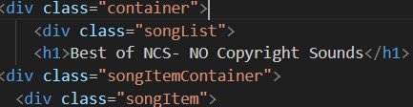
- Container me background-image dalna hai or hrading dalna hai
- Container ko min-height:75vh krne se bottom niche sift hojayega.or container ke liye space bn jayega.

- 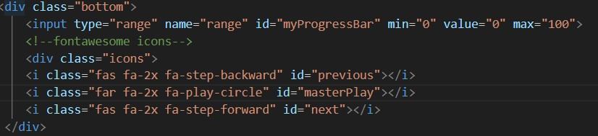
- Bottom ko sticky dene
- Bottom me position:sticky ,hight:130px,background-color:black

